






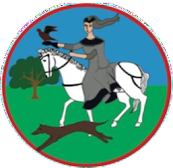
Dear Parents/Carers,
As always, at this time of year, we prepare to say a fond farewell to our Year 6 pupils as they embark on their next exciting chapter. We have enjoyed reminiscing about their time spent at Elizabeth Woodville from Foundation to Year 6.
We are extremely proud of them all and everything they have achieved during their time with us. On behalf of all staff, we wish them continued

success at their next school and in the future.

We have welcomed our new parents and pupils into our EYFS class and look forward to when they join us again after the Summer break.
Our Year 5 and 6 pupils presented us with the fantastic end-of-year show Mission Implausible.
Audiences thoroughly enjoyed the amazing singing and superb acting of everyone involved.

We have enjoyed
another successful
year at Elizabeth
Woodville and are very proud of everything our pupils have achieved.

We wish everyone a happy, healthy and restful summer and look forward to welcoming you back in August.
Andrew Pridmore, Headteacher
Summer Term: July 2025





Headteacher’s Note

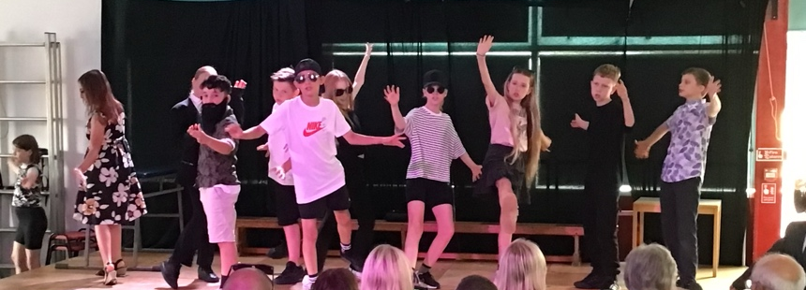
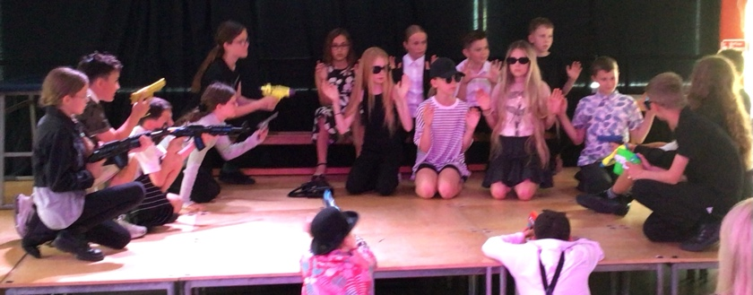


Future stars of the stage!
From beginning to end our Year 5 and 6 pupils thoroughly entertained audiences with their interpretation of the play Mission Implausible. They worked extremely hard over the last few weeks of term to learn lines, song lyrics and stage instructions as well as create their costumes. The show was highly amusing and completely captivating throughout.

Well done to all involved, both staff and pupils for a very professional performance.
Mr Davis will be leaving us to begin his teaching career. During his time at Elizabeth Woodville, Mr Davis has taken several different roles, both in and out of the classroom and touched the lives of many children. He will be greatly missed and we wish him luck in an exciting new chapter.

We come to that time of year when we sometimes say a sad fond farewell to staff.

Mrs Baker works very hard keeping the school clean both during term time and the school holidays.
We wish her a more relaxing time as she leaves us to retire and spend more time with her family.

Congratulations to Miss Fromm who will be leaving us early in the new term on maternity leave. Miss Fromm is a great support to many children and we look forward to when she is back with us later next year.

Contact us at: Elizabeth Woodville Primary School, Glebe Road, Groby LE6 0GT ~ Tel: 0116 287 6050 office@elizabethwoodvilleprimaryschool.co.uk
Year 1

We have been extremely busy in Year 1!

In our PSHE ‘No Outsiders’ lesson, we read a book called Errol’s Garden by Gillian Hibbs. In this story, a community work together to create a garden for them all to enjoy. We worked in our groups to create our own garden using different resources around the classroom.

In Science, we have been
learning about plants. We
went on a plant hunt
outside and drew the
different parts of a plant.

Our geography lessons have been teaching us about the seaside and everything we might find there.

The seaside theme has also been a focus in our music lessons. We have been learning about tempo and we moved quickly and slowly around the room like a diver, sea turtle or dolphin!

Foundation

Our EYFS children had a fantastic time on their recent trip to Tropical Birdland!

The visit was enjoyed by all, with the beautifully coloured parrots - both big and small – being a firm favourite.

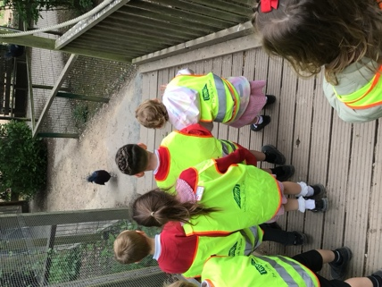
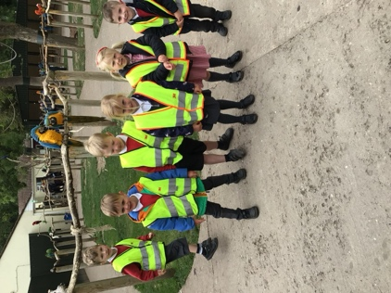
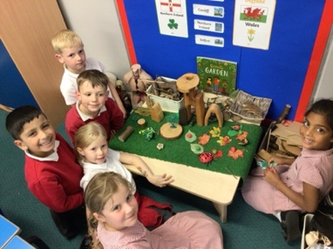

The children were thrilled to have the birds perch on their shoulders, creating lots of smiles and laughter.

The cheeky meerkats provided plenty of entertainment, while the elegant flamingos sparked curiosity – who knew they weren’t born pink?!

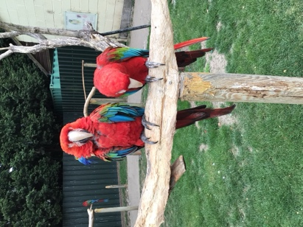
Everyone had a super day, and we’re so proud of how wonderfully the children represented the school throughout the trip.

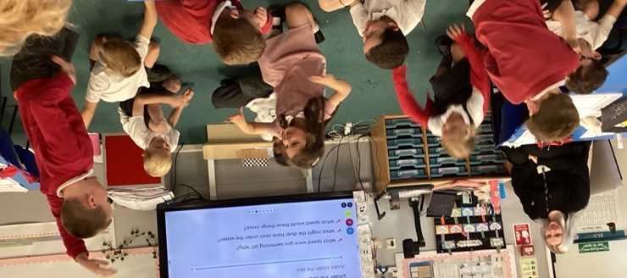

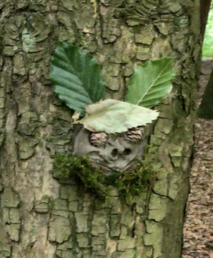
Year 2

It has been a fantastic term in Year 2, with our sunny trip to Beacon Hill being a real highlight! Armed with their favourite teddy bears, the children enjoyed a magical day exploring the woods and taking part in a range of creative and team-based nature activities. They made peg dolls and built woodland shelters, showing great teamwork and imagination. The day was filled with fun as they played hide and seek, practised balancing over log piles, and made some fantastic clay faces for the trees! The children also made their own wands from sticks and crafted beautiful elder wood necklaces to take home.

In class, we have been learning about plants and germination in Science. We have dissected kidney beans to observe embryos, planted sunflower seeds to record the growth, and also grown cress to see what conditions plants need to be able to grow healthily. Our outdoor nature experience linked perfectly, helping the children understand what plants need to grow by observing real woodland examples.

.
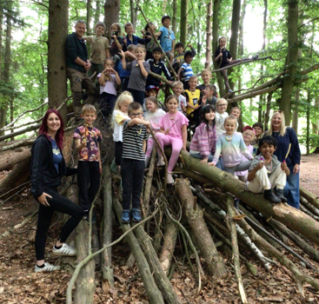
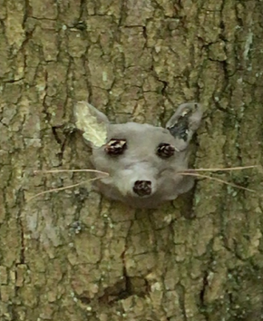
.

Contact us at: Elizabeth Woodville Primary School, Glebe Road, Groby LE6 0GT ~ Tel: 0116 287 6050 office@elizabethwoodvilleprimaryschool.co.uk
Contact us at: Elizabeth Woodville Primary School, Glebe Road, Groby LE6 0GT ~ Tel: 0116 287 6050 office@elizabethwoodvilleprimaryschool.co.uk
Year 4

It’s been a wonderfully creative few weeks in Year 3!

We’ve explored our artistic side through continuous line drawings and impressive 3D flower sculptures.

In PSHE, we've been thinking about the theme of change as we prepare for the move to Year 4, and the children have created thoughtful posters to help explain what empathy means and how we can show it to others.

In Science, we ended the term with a bang as we investigated the fascinating world of forces and magnets.

We also wrapped up our Ancient Greece history unit with an exciting Super Learning Day.
Year 3

Year 4 have had a very busy and productive term. We really enjoyed reading the fantastic book The Lost Happy Endings by Carol Ann Duffy & Jane Ray and wondering what would happen to the main character Jub and the wonderful endings to many stories.

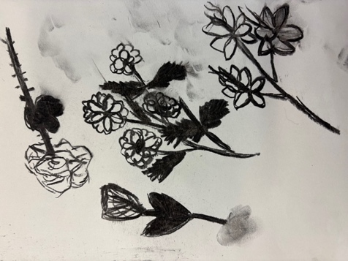
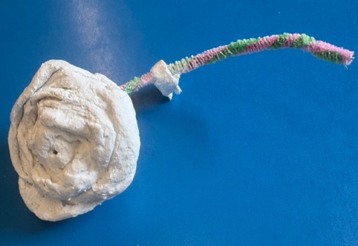
We also created our own Friendship Recipe including ‘a sweet drizzle of happiness, a scoop of magic laughter and lots of respect’!

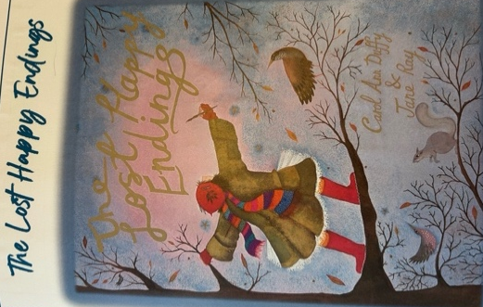

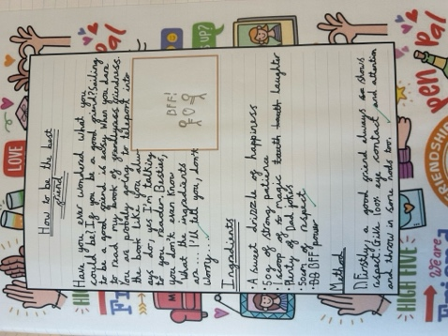

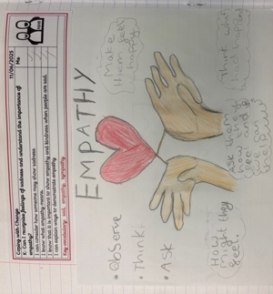
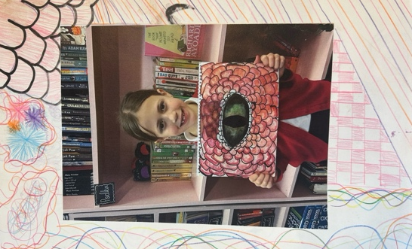
In art, we used various sketching techniques to design our own dragon eyes. We then created our eyes using colour and paint.

Our clay plates using Usaka Koji designs were also chosen to be presented to our partner school, Chengdu Shifan Primary in China.

Year 5 have thoroughly enjoyed immersing themselves in their captivating history topic: the Tudors. One of the highlights of the unit was exploring the fascinating life and legacy of Elizabeth Woodville, a key figure in the turbulent period of the Wars of the Roses.

They also explored the interactive exhibition, which offered a wealth of artefacts which deepened their understanding of the era. The visit truly enriched their learning experience, sparking curiosity and inspiring thoughtful discussions back in the classroom.
Year 5

To bring their learning to life, the pupils embarked on an educational visit to the historic site of the Battle of Bosworth. During the trip, the children took part in a guided walk across the battlefield, where they discovered how this pivotal conflict changed the course of English history.

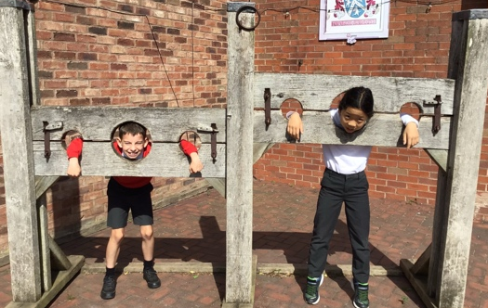
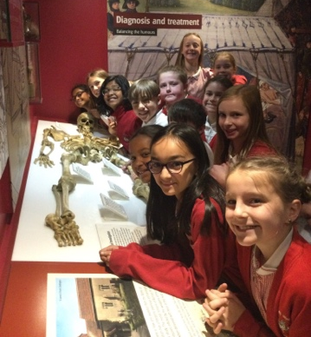

Contact us at: Elizabeth Woodville Primary School, Glebe Road, Groby LE6 0GT ~ Tel: 0116 287 6050 office@elizabethwoodvilleprimaryschool.co.uk

Year 6

As we approach the final weeks of Year 6, it has been a time of reflection, celebration and preparation for the journey to secondary school.

Earlier in this half term, we visited Groby Parish Church to reflect on our time at Elizabeth Woodville and look ahead to the future. The children shared memories of their time at primary school and took some time to consider the exciting changes to come in Year 7. They also enjoyed playing games and singing songs to help them to reflect.

Back at school we have been busy rehearsing the end-of-year play – Mission Implausible. The children have shown fantastic creativity and teamwork; learning lines and songs as well as designing and creating brilliant props. Their enthusiasm has been truly infectious, and they were so looking forward to sharing their fantastic performance.

In our history learning this term, particularly local history, we have continued learning about World War Two, with a focus on the Blitz in Leicester. The children stepped into the shoes of air raid wardens, writing safety instructions and examining real 1940’s newspaper clippings, which they found fascinating.

The children worked extremely hard during their week of
SATs. We were very proud of their attitude and maturity
towards the tests. What a sense of achievement they all
felt by the end of the week.

There’s a growing sense of pride as the pupils wear their
leavers’ jumpers, a symbol of how far they’ve come.

As we near the end of term, we’ll keep building memories
and celebrating all that Year 6 has achieved.

Contact us at: Elizabeth Woodville Primary School, Glebe Road, Groby LE6 0GT ~ Tel: 0116 287 6050 office@elizabethwoodvilleprimaryschool.co.uk

Contact us at: Elizabeth Woodville Primary School, Glebe Road, Groby LE6 0GT ~ Tel: 0116 287 6050 office@elizabethwoodvilleprimaryschool.co.uk

Contact us at: Elizabeth Woodville Primary School, Glebe Road, Groby LE6 0GT ~ Tel: 0116 287 6050 office@elizabethwoodvilleprimaryschool.co.uk

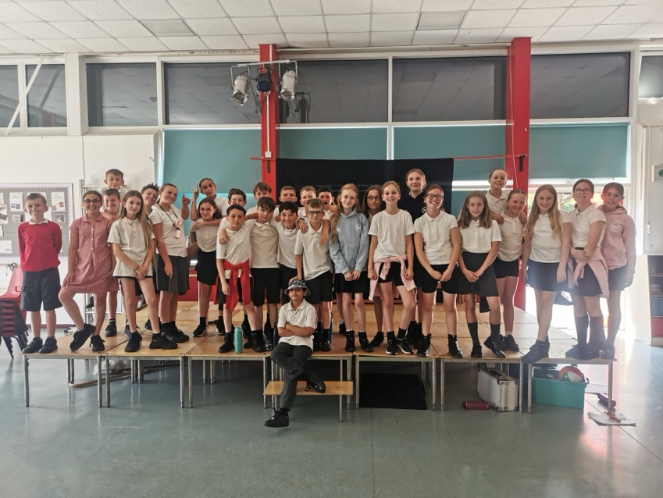

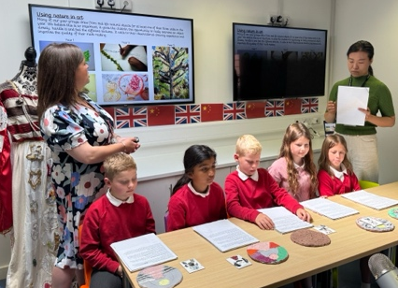

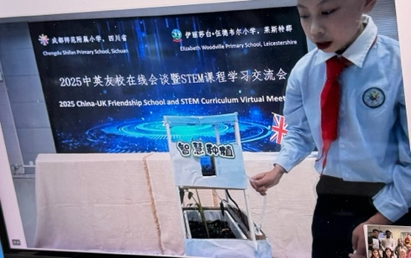
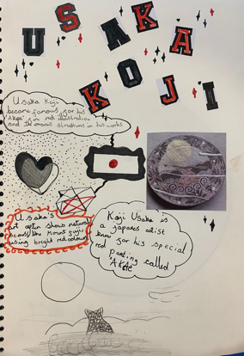
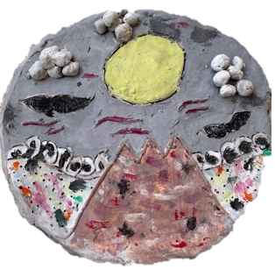

Our pupils from Year 4 were also able to share some of their own fantastic Design and Technology projects. During their learning around the artist Usaka Koji they designed and created some brilliants examples of clay plates and presented these to the children in China.

Thank you to Mrs McLellan, our Year 4 pupils and school governors Mr Bains and Mr Haylock for their help in supporting us to strengthen our relationship with Chengdu Shifan and we look forward to continuing this link in the coming years.
Continued links with China

We are very lucky to continue our close relationship with Chengdu Shifan Primary School in China. This term, we shared our Design and Technology curriculums in an online joint assembly. We were able to see some amazing projects that the pupils in China have been working on – including a self-maintaining garden and a solar-generated roller coaster!

The PTA

A bumper year of fun and fundraising for the school.

On behalf of the PTA, we’d like to extend a heartfelt thanks to our school community for engaging and supporting all our fundraising efforts this academic year. From the penny challenge to monster trails, to movie night, discos, golden ticket event, bingo night, fairs and beyond we really have worked hard to bring new and exciting activities for the children to have a lot of fun whilst raising vital funds for the school.

We’ve been investing the money raised into much needed new equipment such as the new projector in the hall which every child benefits from and we are on track to meeting our fundraising target in order to purchase new iPad’s so that each child in the school can benefit from the new technology and it will mean each child will have access to more new equipment.

We have already booked some very exciting experiences for the children to look forward to in September 2025 – more details will be shared in the new academic year!

In the coming academic year please support us by:
- Joining the PTA – do as little or as much as you can – every bit of support is hugely welcomed and we’re always looking for new ideas!
- Volunteer at each event – an hour is all it takes to make a massive difference.
- Sponsoring our events – If you have your own business or have an employer that could sponsor us so we can raise even more money and promote your business at the same time.

Please note from September 2025 – Without parent support, we will no longer be able to run events in the new academic year
We hope you all have a wonderful summer break.

From everyone in the PTA thank you!

Contact us at: Elizabeth Woodville Primary School, Glebe Road, Groby LE6 0GT ~ Tel: 0116 287 6050 office@elizabethwoodvilleprimaryschool.co.uk

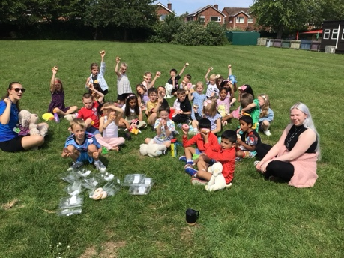
We’re pleased to announce that we have raised just over £11.572.39 this academic year. This is a school PTA record for funds raised by the PTA in the school’s history which is something that our PTA are immensely proud of. Especially as all our members volunteer their time to plan, develop and deliver all the fresh, innovative events that have brought so much joy to the children.

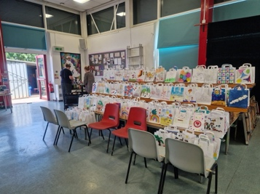
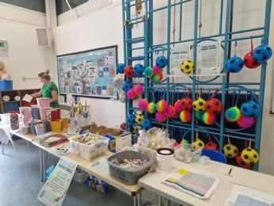

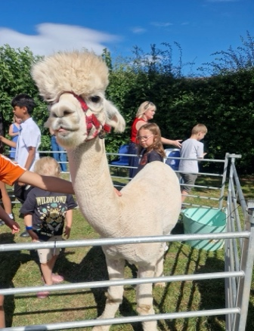
Year 1 enjoying their Golden Ticket prize

Some snapshots of our fantastic Summer Fair

Open the Book

We would like to say a very BIG THANK YOU to our friends at Open the Book.

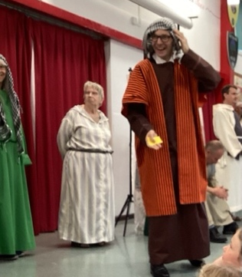

The pupils thoroughly enjoy the monthly assemblies and our surprise guest actor always relishes participating in the action!

We look forward to welcoming ‘Open the Book’ back in the Autumn term.

In the meantime, Churches together in Groby are holding some holiday clubs (see below for details). Pupils are welcome to attend these clubs and have some fun!

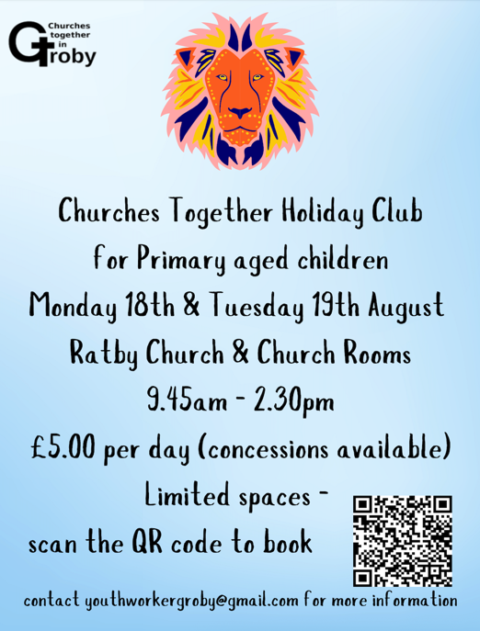
Summer Reading Challenge

Don’t forget to visit
Groby Library and join
the Summer Reading
Challenge. Elizabeth
Woodville pupils excel
in this challenge, year-
on-year and I am sure
will continue to enjoy
their Summer reading.

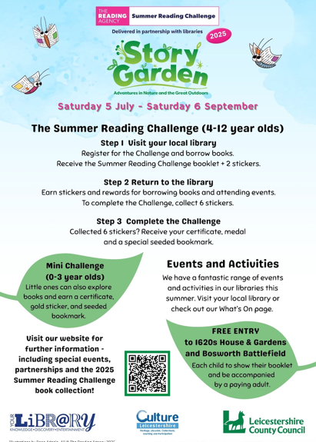


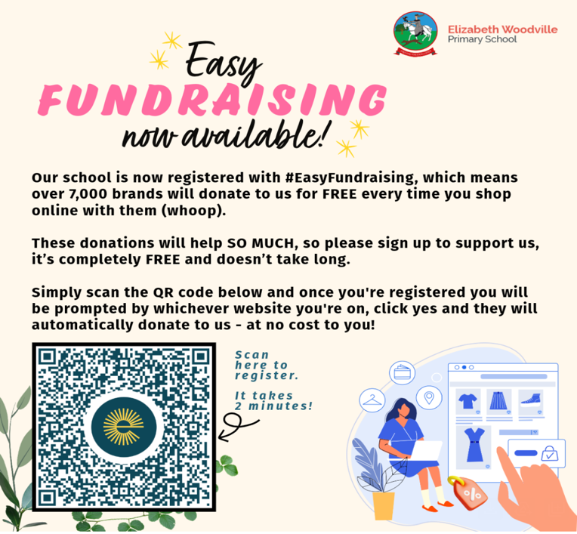




Keep informed about everything happening at Elizabeth Woodville with ‘My Child At School’.

Remember to enable notifications to get the latest news and information about events in school.
A very happy Summer
from all staff and
pupils at EWPS

Wednesday 27th August: School Opens

20th to 24th October: Mid-term break
Contact us at: Elizabeth Woodville Primary School, Glebe Road, Groby LE6 0GT ~ Tel: 0116 287 6050 office@elizabethwoodvilleprimaryschool.co.uk

